**Loneliness ‘kills like smoking’: solitude linked to heart disease**

* The Times
* 12:00AM April 21, 2016
  + [Share on Facebook](http://facebook.com/sharer.php?u=http%3A%2F%2Fwww.theaustralian.com.au%2Fnews%2Fworld%2Fthe-times%2Floneliness-kills-like-smoking-solitude-linked-to-heart-disease%2Fnews-story%2F2abce808a66dcf866b473650a83328c6&t=Loneliness%20%E2%80%98kills%20like%20smoking%E2%80%99)
  + [Share on Twitter](https://twitter.com/intent/tweet?url=http%3A%2F%2Fwww.theaustralian.com.au%2Fnews%2Fworld%2Fthe-times%2Floneliness-kills-like-smoking-solitude-linked-to-heart-disease%2Fnews-story%2F2abce808a66dcf866b473650a83328c6&text=Loneliness%20%E2%80%98kills%20like%20smoking%E2%80%99)
  + [Share on email](mailto:?subject=Loneliness%20%E2%80%98kills%20like%20smoking%E2%80%99&body=http%3A%2F%2Fwww.theaustralian.com.au%2Fnews%2Fworld%2Fthe-times%2Floneliness-kills-like-smoking-solitude-linked-to-heart-disease%2Fnews-story%2F2abce808a66dcf866b473650a83328c6)
  + [Share more...](http://www.theaustralian.com.au/news/world/the-times/loneliness-kills-like-smoking-solitude-linked-to-heart-disease/news-story/2abce808a66dcf866b473650a83328c6#share-tools)
* [8](http://www.theaustralian.com.au/news/world/the-times/loneliness-kills-like-smoking-solitude-linked-to-heart-disease/news-story/2abce808a66dcf866b473650a83328c6#comments)

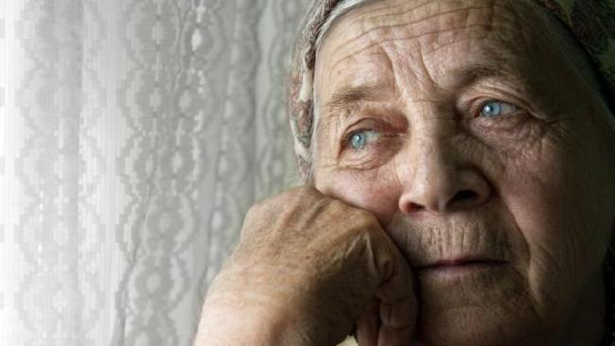

Isolation has previously been linked to dementia and early death.

Loneliness can increase the risk of heart disease by a third and must be treated as seriously as obesity and smoking, experts have said.

Researchers said the risk might be even higher than estimated if loneliness was the root cause of unhealthy habits such as poor diet or inactivity.

A million older people in Britain say they are lonely and isolation has previously been linked to dementia and early death. One study found lonely people were 50 per cent more likely to die early, a similar risk to smoking and drinking.

“What that doesn’t tell you is whether people are at greater risk of developing disease or if people who are ill are less likely to recover if they’re lonely,” said Nicole Valtorta, of the University of York, who led the latest research.

She analysed data from 23 studies involving 180,000 people to conclude that lonely people were also more likely to get heart disease or have a stroke.

“When we aggregated the effect estimates across the studies we found that people with weaker social relationships had a 29 per cent greater risk of developing coronary heart disease than the people with stronger social relationships,” Dr Valtorta said. “And similarly when we looked at stroke, the effect estimates taken across the evidence suggested that people who are socially isolated had a 32 per cent greater risk of developing a stroke.”

Loneliness could cause disease through direct effects on the immune system or blood pressure, through the effects of depression or because it makes people turn to cigarettes, alcohol and junk food, scientists believe.

*The Times*